**Lesson 1.1 Solution**

1. Number of nodes in the West Jordan Network = **149**

Number of zones in the West Jordan Network = 41

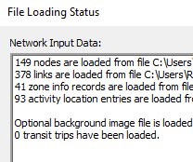

1. Speed Limit = 32mph

Number of lanes = 2

Attaching the snapshot for further reference

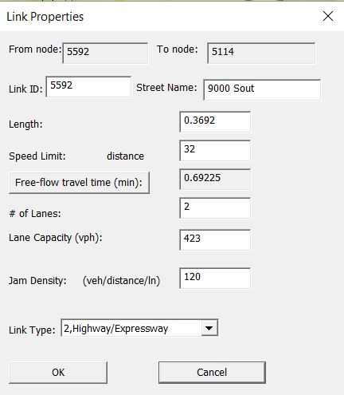

1. Link capacity refers to the capacity of the link joining 2 nodes.

Lane capacity is the total number of vehicles that can travel in a lane in a link per hour.

1. The following Histogram shows the network capacity of Redwood road.

The bar in red colour shows the average capacity = 384.84

There would be bottleneck in the 5208, 5238 links as these have 2 links with variable capacities of 446 and 929.5 respectively.

1. 2513 vehicles need to be simulated.
2. The following table shows the routing iteration along with all the components for the base condition:



Average Travel time = 5.67 min

Average Speed = 33.12

Network clearance time = 1440

Average Trip Time Index = 1.01

As the number of iterations increases the travel time eventually reduces to the optimum value, even though there is a scatter all over but the trend line decreases.

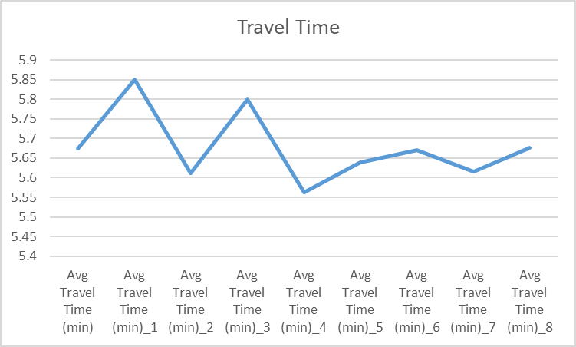

1. The following table shows the routing iteration along with all the components of the work zone :



Average Travel time = 5.71 min

Average Speed = 32.88

Network clearance time = 1440

Average Trip Time Index = 1.022

1. The following images shows the comparison between both the networks:

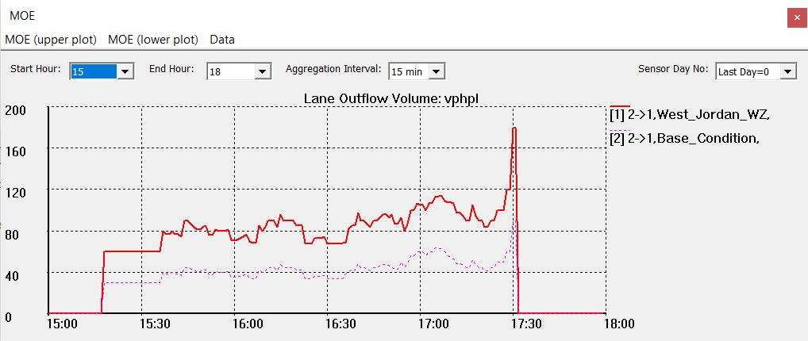

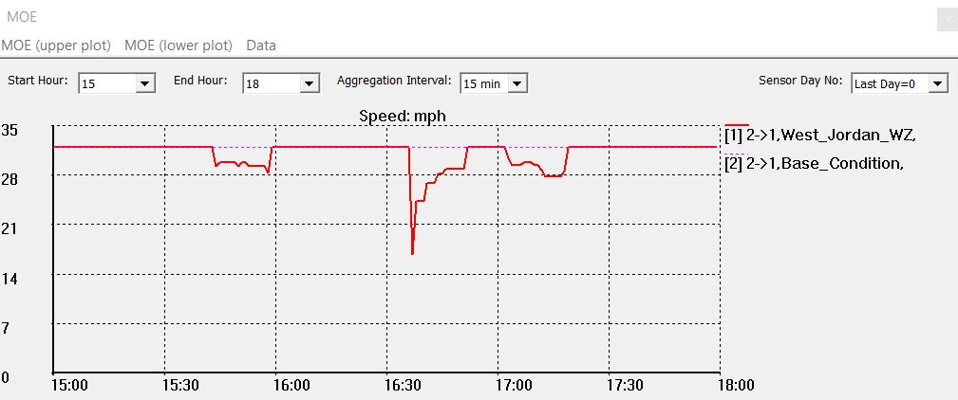

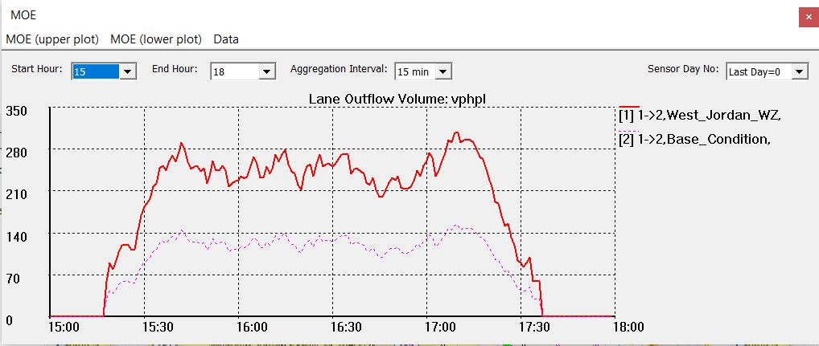

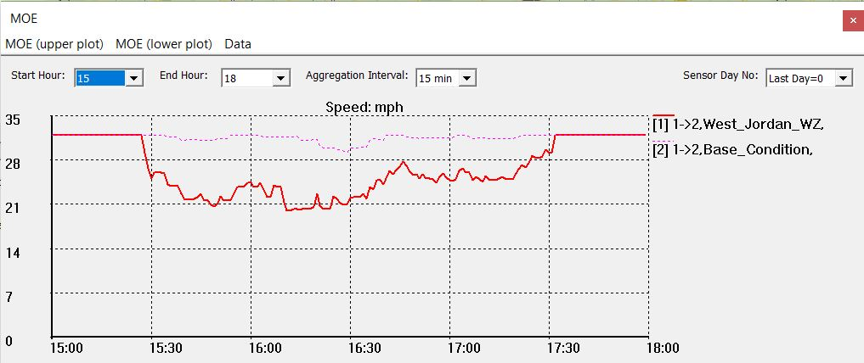

1. It can be observed that the speed in the work zone network is slower than the one without work zone as shown in the picture above. The vehicle per hour per lane is also high in the work zone, which makes sense as the work zone has closed off 1 lanes in each direction.